Bulk Messaging

📦 What Is Bulk Messaging?
# Source: Chatgpt (GPT-5-Mini) at [1/21/2026]
Bulk messaging refers to the process of sending a large number of SMS, emails, or other messages to multiple recipients at once, often for marketing, notifications, or information dissemination.
🧠 Think of it as "copy-paste" to thousands of users, but done automatically through software or an API.

📲 Example Use Cases:
# Source: Chatgpt (GPT-5-Mini) at [1/21/2026]
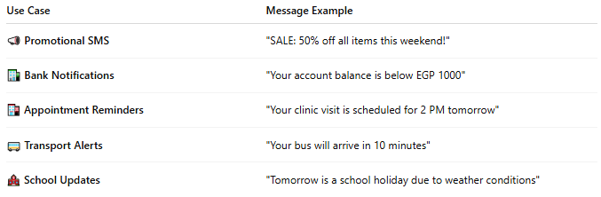

Use Case | Message Example
📣 Promotional SMS | "SALE: 50% off all items this weekend!"
🏦 Bank Notifications | "Your account balance is below EGP 1000"
🏥 Appointment Reminders | "Your clinic visit is scheduled for 2 PM tomorrow"
🚌 Transport Alerts | "Your bus will arrive in 10 minutes"
🏫 School Updates | "Tomorrow is a school holiday due to weather conditions"

🧠 Key Characteristics:
# Source: Chatgpt (GPT-5-Mini) at [1/21/2026]
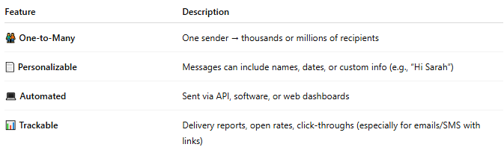

Feature | Description
🧑‍🤝‍🧑 One-to-Many | One sender → thousands or millions of recipients
📄 Personalizable | Messages can include names, dates, or custom info (e.g., “Hi Sarah”)
💻 Automated | Sent via API, software, or web dashboards
📊 Trackable | Delivery reports, open rates, click-throughs (especially for emails/SMS with links)

⚙️ How Bulk Messaging Works:
# Source: Chatgpt (GPT-5-Mini) at [1/21/2026]
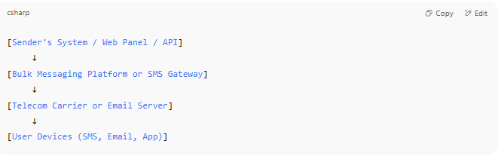

[Sender's System / Web Panel / API]
↓
[Bulk Messaging Platform or SMS Gateway]
↓
[Telecom Carrier or Email Server]
↓
[User Devices (SMS, Email, App)]

🛠️ Tools & Technologies:
# Source: Chatgpt (GPT-5-Mini) at [1/21/2026]
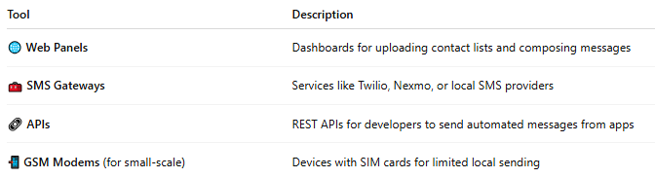

Tool | Description
🌐 Web Panels | Dashboards for uploading contact lists and composing messages
🧰 SMS Gateways | Services like Twilio, Nexmo, or local SMS providers
🔗 APIs | REST APIs for developers to send automated messages from apps
📲 GSM Modems (for small-scale) | Devices with SIM cards for limited local sending

🆚 Bulk Messaging vs Mass Broadcast:
# Source: Chatgpt (GPT-5-Mini) at [1/21/2026]
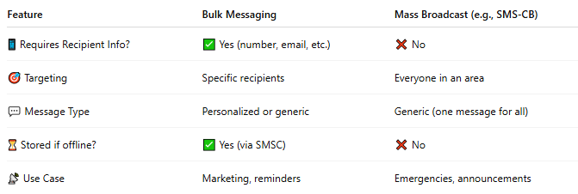

Feature | Bulk Messaging | Mass Broadcast (e.g., SMS-CB)
📱 Requires Recipient Info? | ✅ Yes (number, email, etc.) | ❌ No
🎯 Targeting | Specific recipients | Everyone in an area
💬 Message Type | Personalized or generic | Generic (one message for all)
⏳ Stored if offline? | ✅ Yes (via SMSC) | ❌ No
📡 Use Case | Marketing, reminders | Emergencies, announcements

✅ Benefits:
# Source: Chatgpt (GPT-5-Mini) at [1/21/2026]
- 💸 Cost-effective for large campaigns
- 📈 Scalable from 100 to millions of messages
- 🧠 Smart features: personalization, scheduling, analytics
- 🔒 Often includes opt-out and compliance tools

📖 Summary:
# Source: Chatgpt (GPT-5-Mini) at [1/21/2026]
Bulk messaging is:
- 🧾 A method to send large volumes of messages to known users
- 📞 Often used in marketing, notifications, and alerts
- ⚙️ Powered by APIs, gateways, or platforms
- 🆚 Different from mass broadcast because it targets specific recipients, not general public

